**PROJECT ON C#**

**Copy method of String class in C#**

# Using c#

## Bachelor of Computer Application

**[BCA - 4th]**

**Submitted To:-**

## Shree H.N.Shukla College



**Affiliated To:-**

**Saurashtra University,Rajkot**

**Guided :- prepared :-**

## Mayur Sir Arjun K. Parmar

|  |  |
| --- | --- |
| **SR. NO** | **INDEX** |
| **1** | PREFACE |
| **2** | ACKNOWLEDGEMENT |
| **3** | STUDENT PROFILE |
| **4** | INTRODUCTION OF YOUR PROJECT |
| **5** | PROJECT PROFILE |
| **6** | SYSTEM DESIGN |
| **7** | PROJECT CODING |
| **8** | CONCLUSION |
| **9** | BIBLIOGRAPHY |

### PREFACE

**My Project is about Copy method of String class in C#**

**C# (pronounced "See Sharp") is a modern, object-oriented, and type-safe programming language. C# enables developers to build many types of secure and robust applications that run in .NET.**

**From my program you will learn copy methods of string class in c#.**

### ACKNOWLEDGEMENT

**I would thanks to my class teacher Mayur sir who gives me way to how I create this project and also thanks to sangita mam who helps me in some little things like editing and basic codes.**

**Many people have contributed to make this project a reality, and I would like to thank them all. I guess I should start with the our Admin who has encouraged us to do project with our best efforts.**

**I express my sincere gratitude Mayur Sir(Project Guide) for his timely help and guidance at every stage of execution and development of the project. He always encouraged me. Whenever i have any kind of problem, he paid attention to them**.

**My special thanks to our college staff who is very much co-operative & helpful throughout the LAB session. Without their co-operation project would not be successful. They taught me on how project can be better and successful.**

**STUDENT PROFILE**



|  |  |
| --- | --- |
| **NAME :** | **Parmar Arjun Kishorbhai** |
| **ADDRESS :** | **“Saidham”, Hemavant Society, Khamdhrol Road,Junagadh-362001.** |
| **COLLEGE :** | **H.N.Shukla Group Of Colleges** |
| **STREAM :** | **BCA** |
| **CLASS :** | **4C** |
| **MOBILE NUMBER :** | **9328082187** |
| **WHATSAPP NUMBER :** | **9328082187** |
| **EMAIL ADDRESS :** | **akp@gmail.com** |
| **BASIC SKILL :** | **C#** |
| **CERTIFICATES, HONORS AND AWARDS IF**  **ANY :** | **--** |
| **SKILL AND PROFESSIONAL SUMMARY :** | **--** |

**INTRODUCTION**

**My Project about copy method of string class in c# programming language.**

**Copy methods of string class :-**

**From my program we will know how many methods of copy is present in string class.**

**The C# Copy() method is used to create a new instance of String with the same value as a specified String. It is a static method of String class. Its return type is string.**

**The Copy() method returns a String object, which is the same as the original string but represents a different object reference.**

**To check its reference, use assignment operation, which assigns an existing string reference to an additional object variable.**

**PROJECT PROFILE**

|  |  |
| --- | --- |
| **Project –Title OR Definition :** | **College Management** |
| **Institute:** | **Shree H. N. Shukla College** |
| Language: | C# |
| Back-End: | --- |
| Project-duration: | February |
| Developed for: | Information about copy method |
| Web Browser | Mozila Firefox,  Google Chrome,  Uc Browser |
| Project Guide: | Mayur Sir |
| Developed By: | Arjun **Kishorbhai** Parmar |
| Submitted To: | Saurastra University |

### 

### PROJECTDESIGN

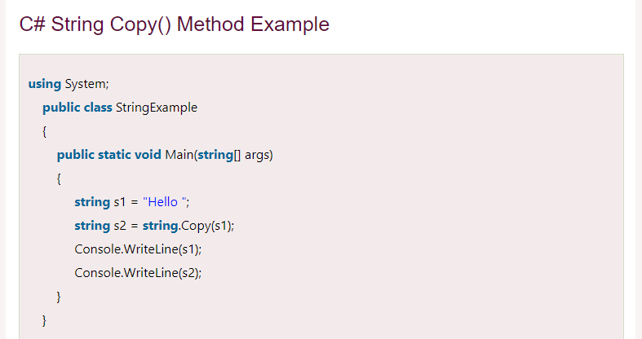

**CONCLUSION**

**This method accepts single parameter str which is the original string to be copied. And it returns the string value, which is the new string with the same value as str. The type of Copy() method is System.String.**

**Syntax:**

**public static string Copy(string str)**

**Above method return newly created instance with value of passed string.**

**To check its reference, use assignment operation, which assigns an existing string reference to an additional object variable.**

**BIOGRAPHY**

* **WebSites :-**
* [**www.google.com**](http://www.google.com)
* [**www.javatpoint.org**](http://www.javatpoint.org)
* [**www.geeksforgeeks.com**](www.geeksforgeeks.com%20)
* [**www.fontawesome.com**](http://www.fontawesome.com)
* [**www.cdnjs.com**](http://www.cdnjs.com)
* [**www.googlefonts.com**](http://www.googlefonts.com)
* [**www.pixabay.com**](http://www.pixabay.com)
* [**www.w3schools.com**](http://www.w3schools.com)
* [**www.bootstrap.com**](http://www.bootstrap.com)
* **Search Engines :-**
* [**www.google.com**](http://www.google.com)
* [**www.firefox.com**](http://www.firefox.com)